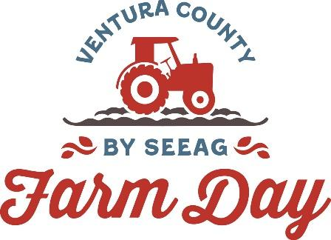

Contacts:
Mary Maranville
Students for Eco-Education and Agriculture (SEEAG)
805-892-8155
mary@seeag.org

Diane Rumbaugh
805-493-2877
diane@rumbaughpr.com

Apricot Lane Farms Added to the Ventura County Farm Day Lineup
Ventura, Calif. (October 25, 2023)—Apricot Lane Farms, the home of the award-winning “Biggest Little Farm” documentary, is a participant in the 11th Annual Ventura County Farm Day, Saturday, November 4. The farm was added this week.

The Moorpark farm is offering free Farm Day Tours on a first come, first served basis. Pre-registration is required to enter the farm—use this Eventbrite link. Parking is limited, so carpooling is suggested.
Founded in 2011 by John and Molly Chester, Apricot Lane Farms currently spans 234 acres of countryside in Moorpark. It cultivates more than 200 varieties of fruits and vegetables; and raises sheep, cows, pigs, chickens and ducks with care and respect. The farm is Certified Organic and Biodynamic.

In addition to Apricot Lane Farms, over 15 other farms and agriculture organizations are taking part in Ventura County Farm Day, opening their doors to the public to participate in free tours, product giveaways and tastings.

Participants in Farm Day include Reiter Affiliated Companies (berries), Driscoll’s (strawberries), Duda Farm Fresh Foods (row crops), Alpacas At Windy Hills (Alpaca fleece), Oxnard Historic Farm Park (antique farm equipment, vegetable crops), Agromin (organic compost, mulch), McGrath Family Farm (organic farming) and SEEAG’s Farm Day Hub at Petty Ranch (orchard tours, exhibits, hands-on farm-related kids’ activities).

Check the Farm Day Trail Map at https://venturacountyfarmday.com/map/
for the latest list of participants. The public can avoid entry lines at each venue by registering in advance at My805Tix (https://www.my805tix.com/e/venturafarmday).

The nonprofit 501(c)(3) Students for Eco-Education and Agriculture (SEEAG) organizes Ventura County Farm Day. SEEAG’s mission is to educate students and the greater community about the farm origins of our food and agriculture's contribution to our nutritional well-being. For more information about Ventura County Farm Day and a list of participating farms, visit www.VenturaCountyFarmDay.com, email seeag.education@seeag.org or call 805-892-8155.
###

